FINAL PROJECT

OSYS1200 – Introduction to Windows Administration

NSCC

Ricardo Oliveira

W0428722

# Introduction

Final project for Intro to Windows Administration course – OSYS 1200. The objective of this paper is to display accurately the completion of the textbook tasks: 13-1 to 13-6, accordingly to the proposed rubric, demonstrating by the display of screenshots of the task results and the rubric completion.

# Task 13-1 Installing a Domain Controller

Create a virtual machine with Windows Server 2016 Std (Desktop), activated, with the network properly configured, and with the AD DS and RDS roles correctly installed, using the proper name convention.

## Screenshots:

### Installation/Activation/Naming:

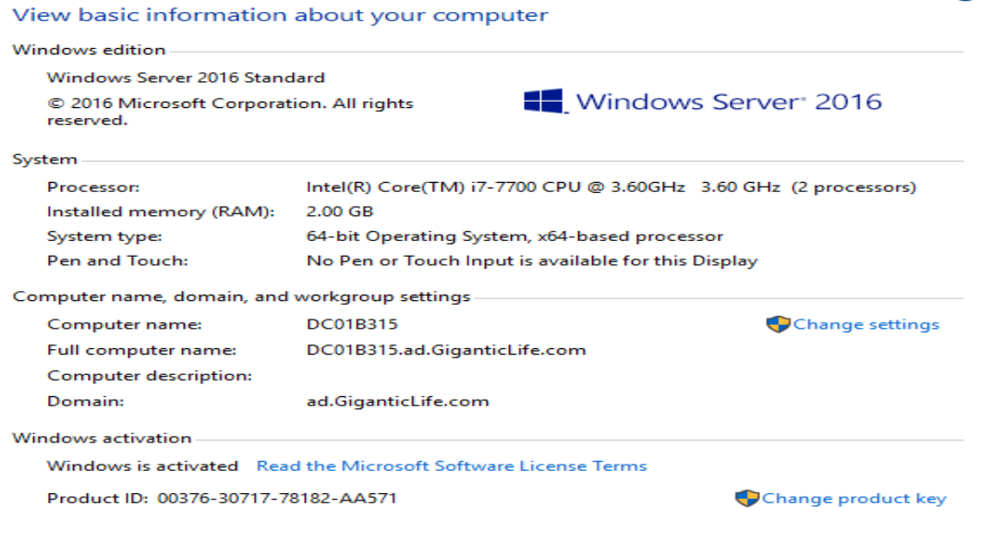

### Network conf:

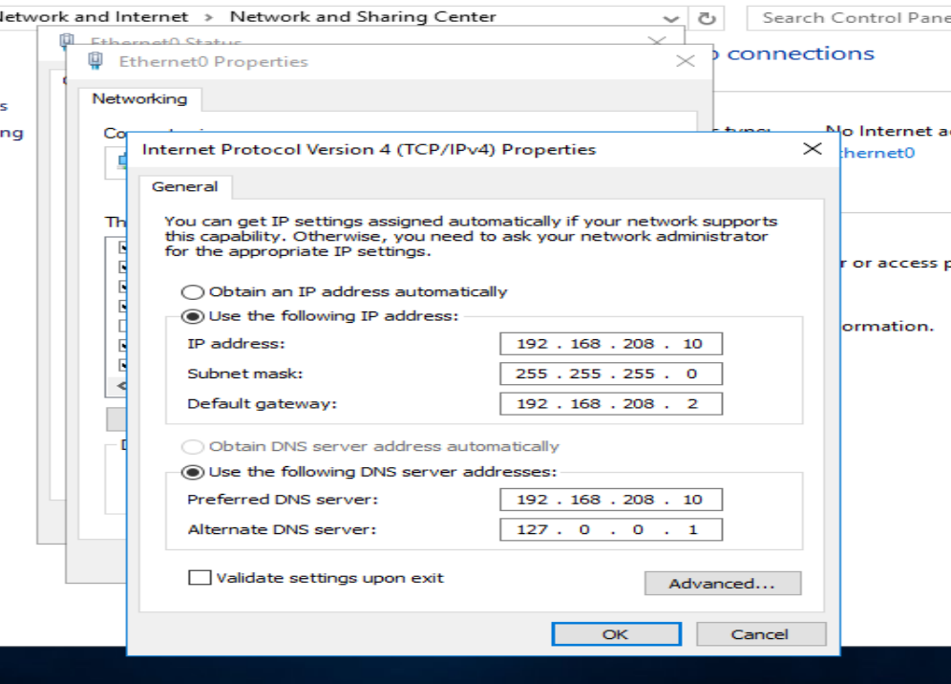

### Server Roles – AD DS and RDS:

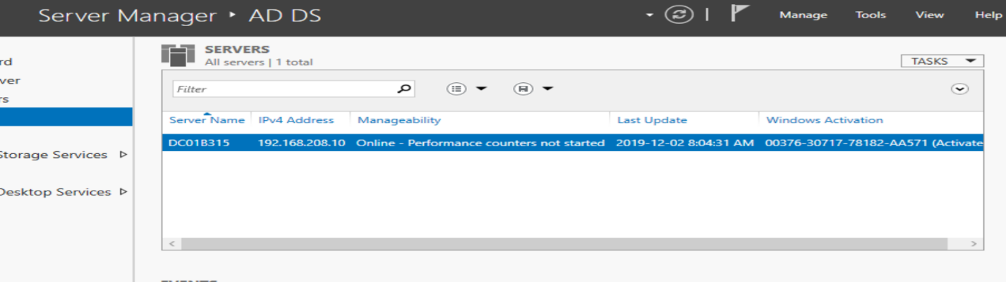

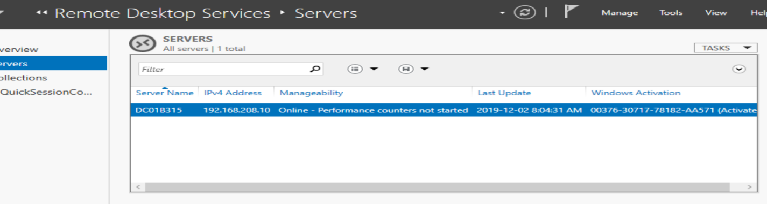

# Task 13-2 Viewing AD DNS Records

Learning the location and how to check the DNS records on the Domain Controller

## Screenshots:

### DNS record used by client to locate the DC(5):

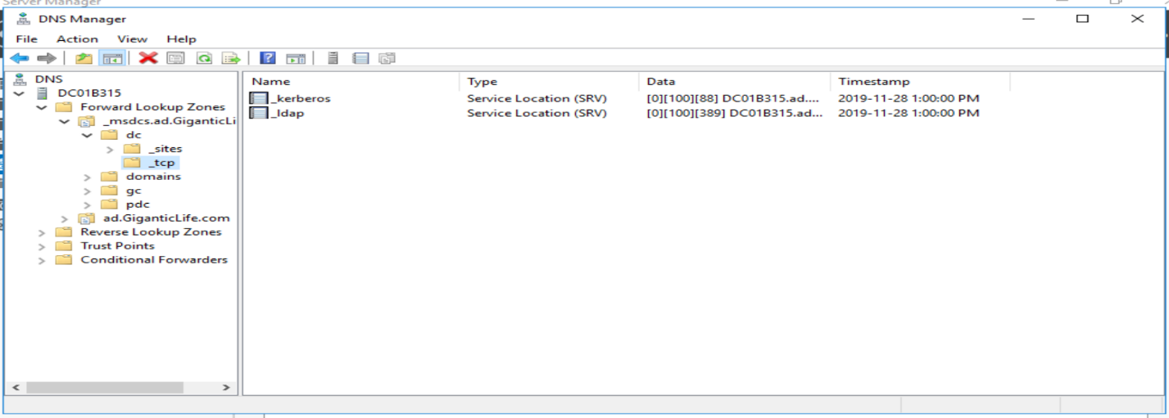

### Default DNS for the server location(6):

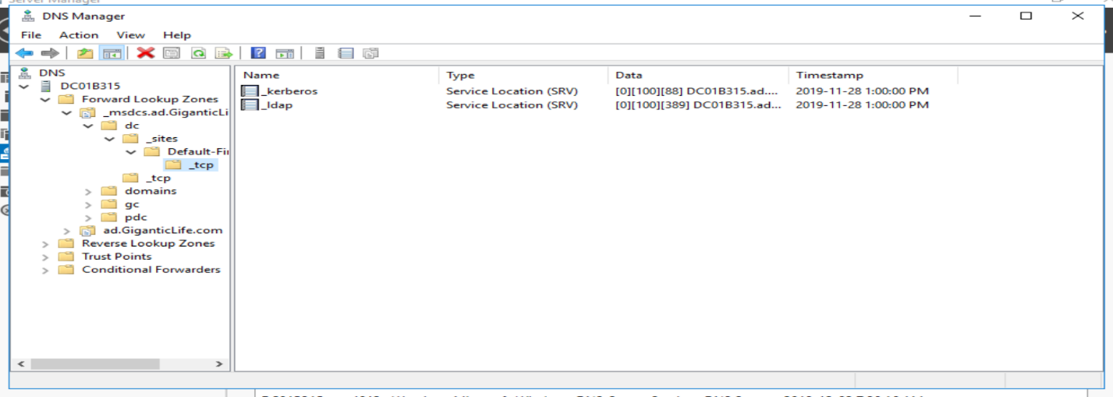

# Task 13-3 Joining a Domain

Correctly configure the WS network and join the domain provided by the DC:

## Screenshots:

### Domain change confirmation:

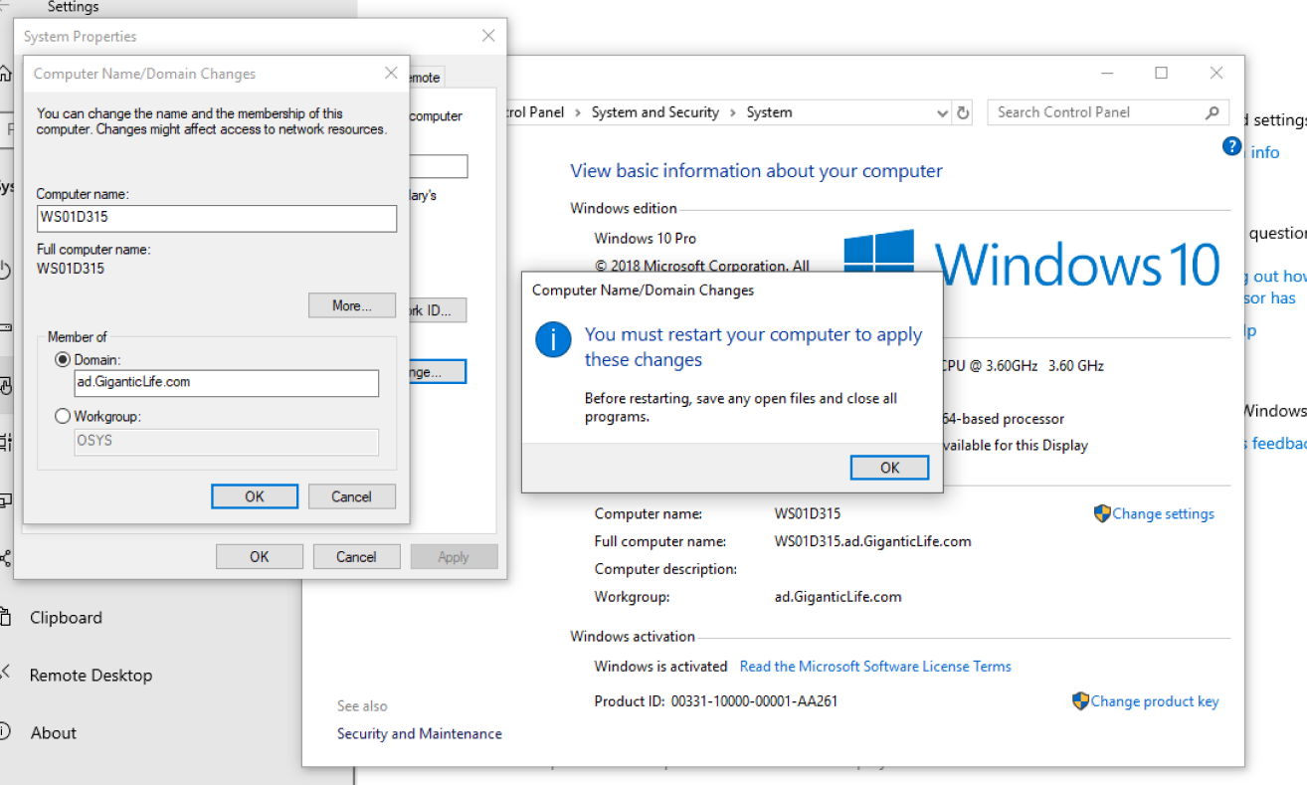

### PowerShell CMD to check the trust network between WS and DC:

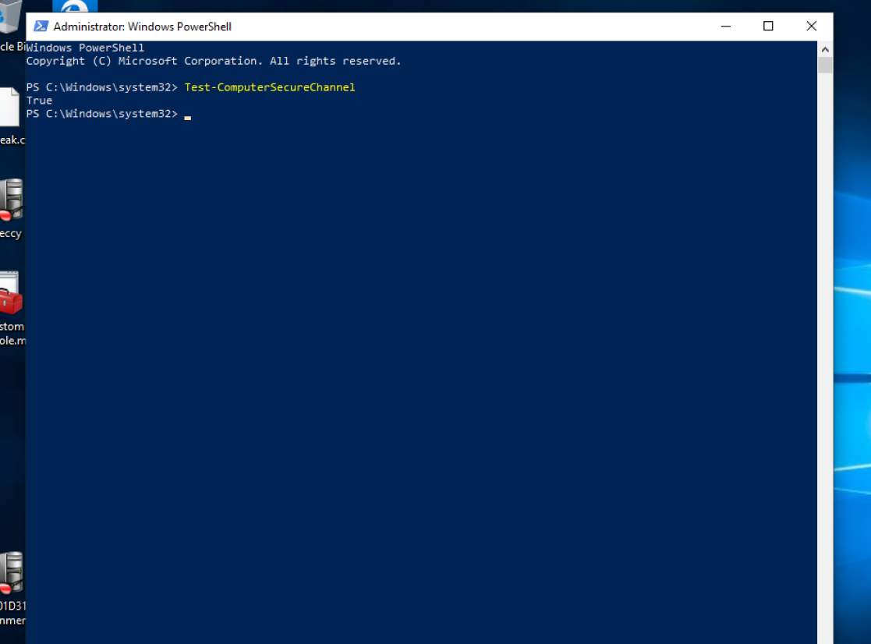

# Task 13-4 Creating a GPO (Group Policy Object)

Create and implement a Group Policy Object, setting some parameters from the DC and implementing them on the WS.

## Screenshots:

### GPO created on the DC(Disabling Task Manager for the WS):

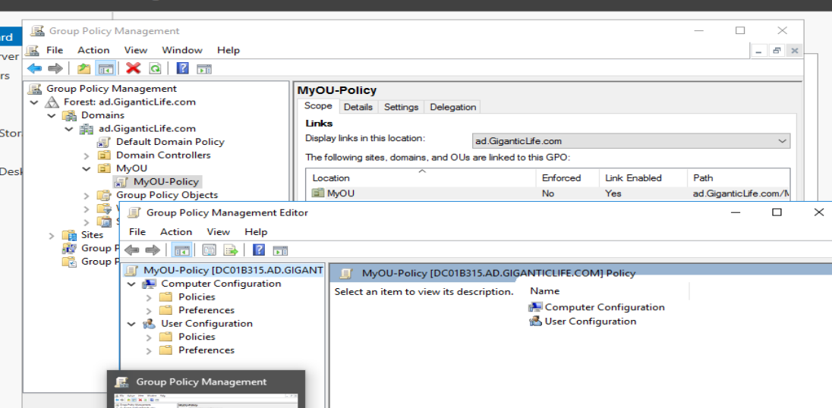

### WS GPO Update/implement:

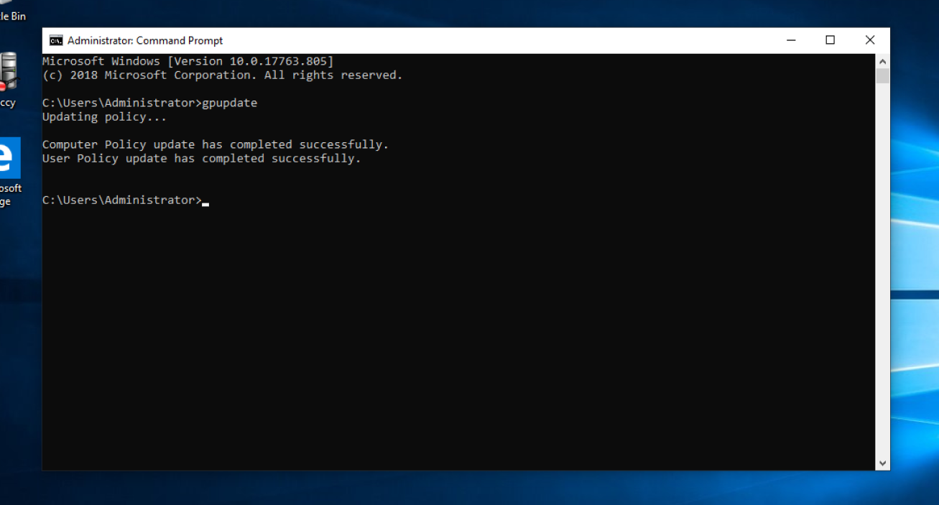

### WS GPO in action(No Task Manager):

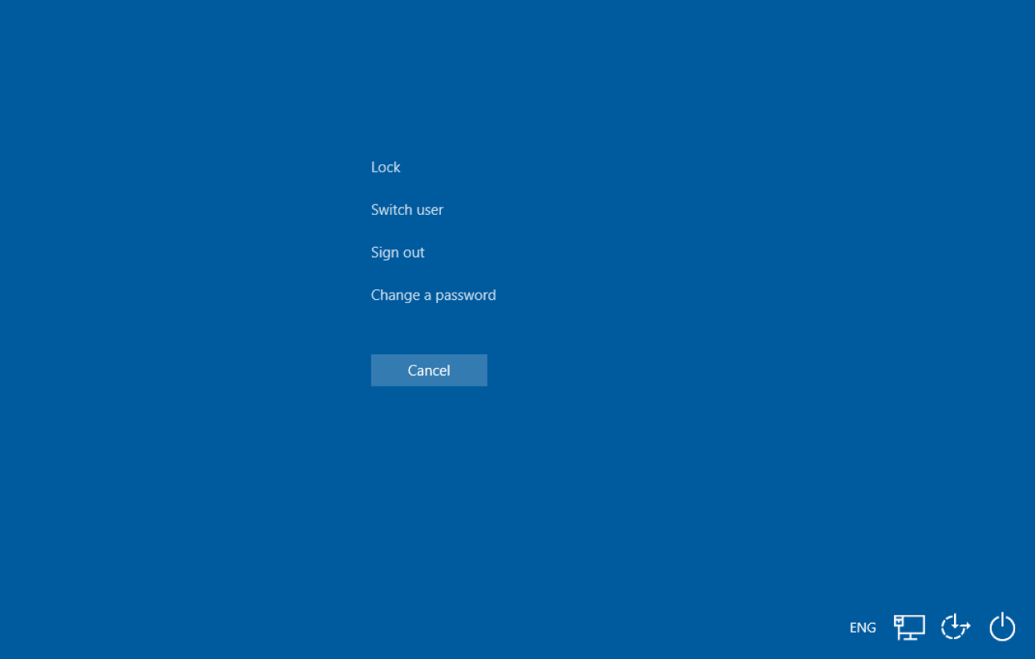

# Task 13-5 Generating a report for GPO Troubleshooting

WS Report of the implemented GPO for troubleshooting.

## Screenshot:

### Command Prompt

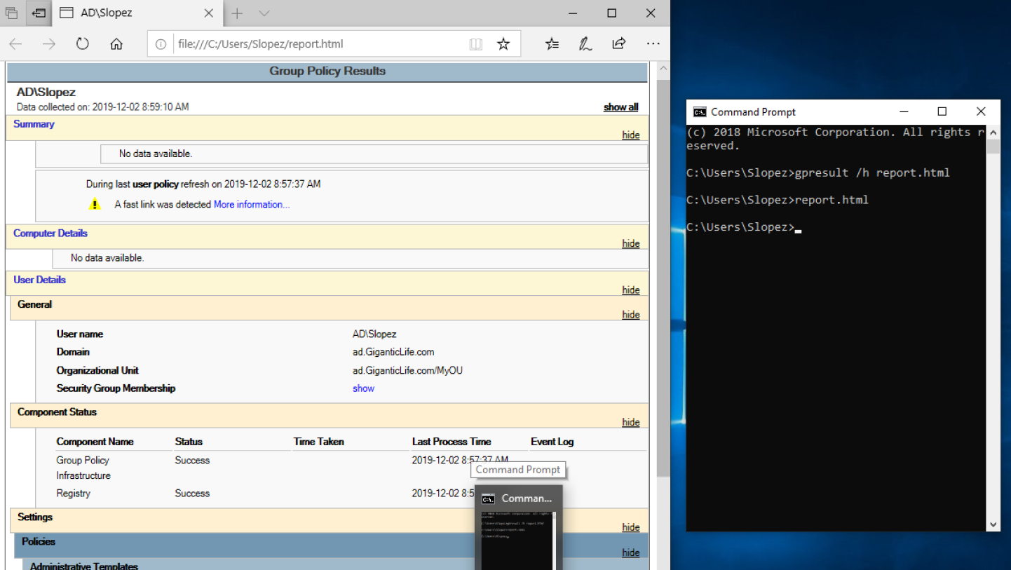

### HTML Report:

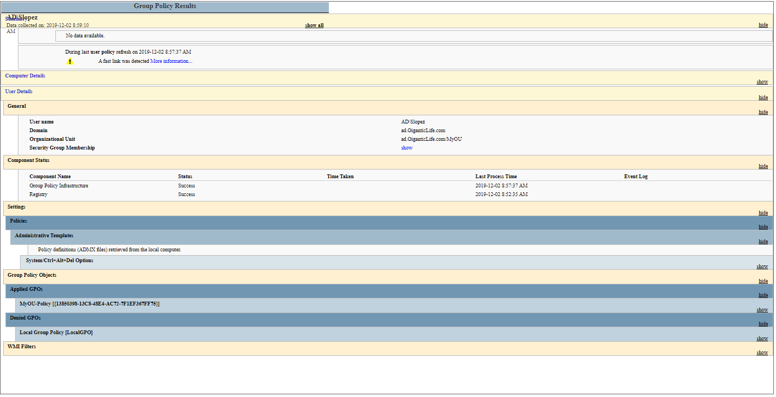

# Task 13-6 Configuring Group Policy Preferences

Configuring GPO – Mapping a drive and sharing the file drive by the DC – Problem detected – WS already used the drive letter – Solved by changing the drive letter provided by the textbook.

## Screenshots:

### Mapping Drive policy

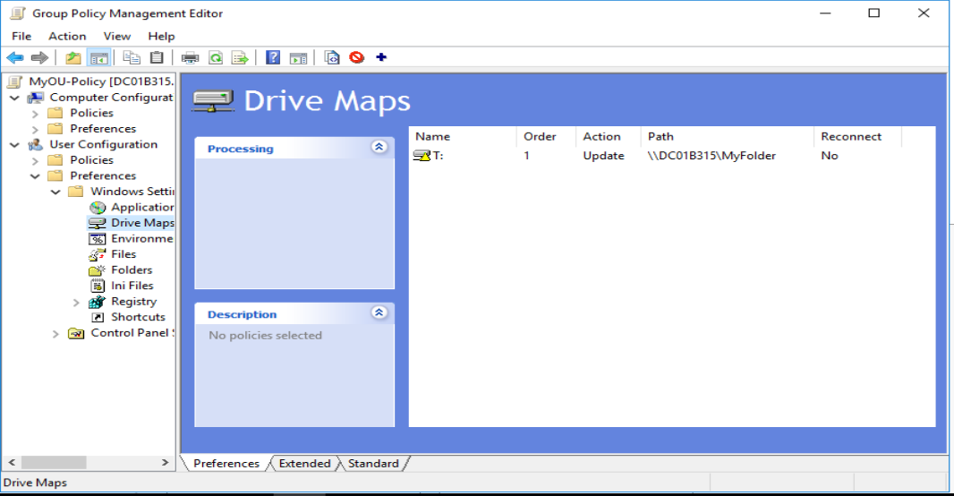

### Network Shared Folder

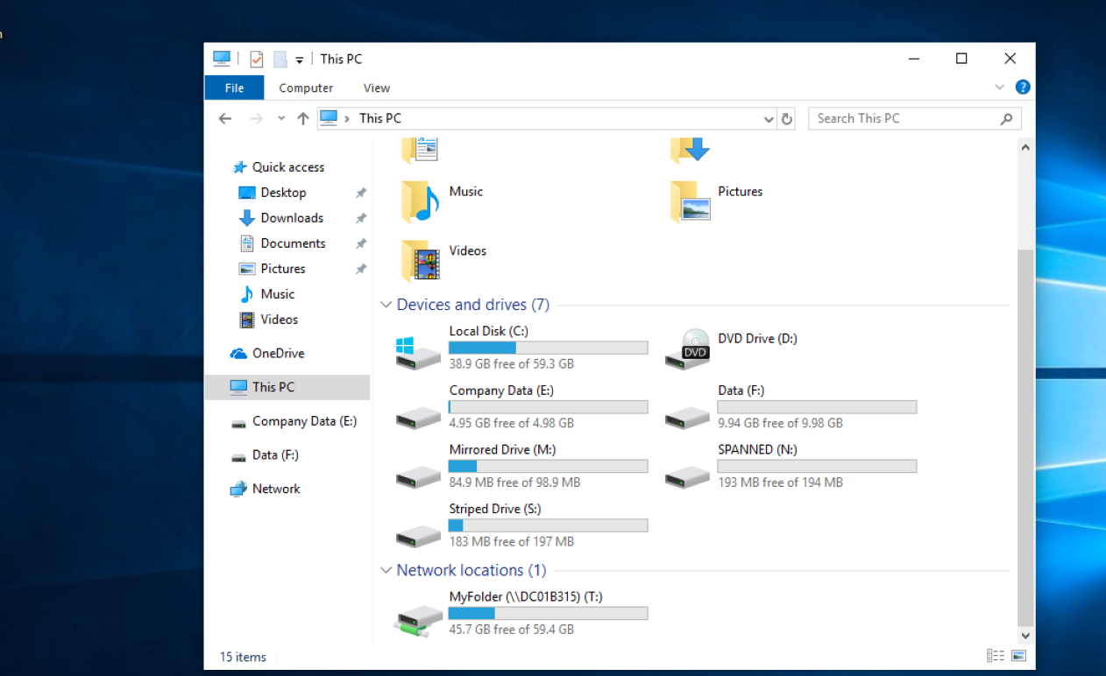

# Changelog

## Server Install Log

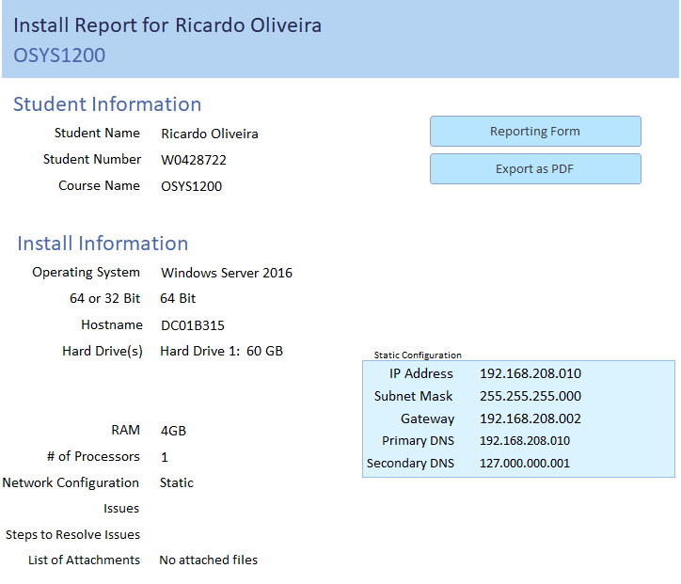

## Server Change Log

## WS Change Log

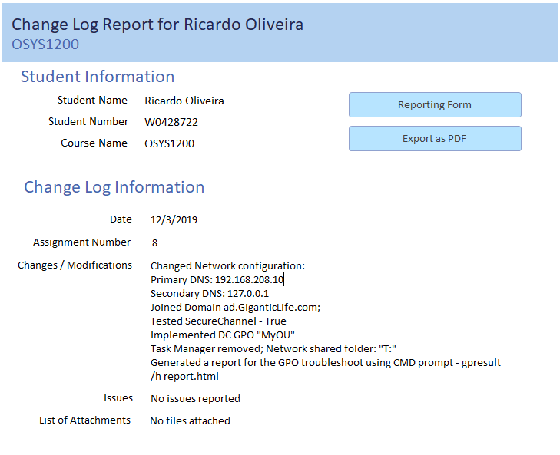

# Works Cited

Wright & Plesniarski(2017) *Microsoft Windows 10 Configuring Windows Devices*, pp. 482-492.

NSCC. (2019, 12 03). OSYS 1200/Introduction to Windows Administration(B)/ Hinton, Pete/4013. Retrieved from Assessments/Assignments/Final Project*:* <https://nscconline.desire2learn.com/d2l/home/125738>